CMPG322
Exercise 8.2 – Equilibrium and absorbing states

- Set up both the vector of state probabilities and the matrix of transition probabilities given the following information:
    - Store 1 currently has 40% of the market; store 2 currently has 60% of the market.
    - In each period, store 1 customers have an 80% chance of returning and a 20% chance of switching to store 2.
    - In each period, store 2 customers have a 90% chance of returning and a 10% chance of switching to store 1.
  - Find π(2) for this problem.
  - Find the equilibrium conditions this problem. Explain what it means.

- Lulu is a surfer who lives in Conway, South Carolina. Through experience, she has determined the transition probabilities for surf conditions from any one day to the next at nearby North Myrtle Beach:
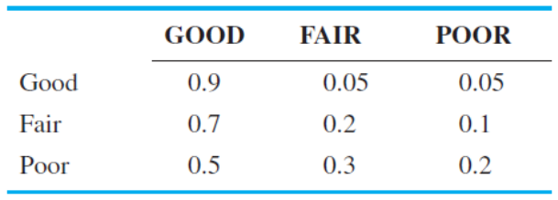
Determine the equilibrium probabilities of good, fair, and poor surf conditions. What does this tell you about surfing conditions in general at North Myrtle Beach?

- (Problem 5 from Exercise 1) The University of South Wisconsin has had steady enrolments over the past 5 years. The school has its own bookstore, called University Book Store, but there are also three private bookstores in town: Bill’s Book Store, College Book Store, and Battle’s Book Store. The university is concerned about the large number of students who are switching to one of the private stores. As a result, South Wisconsin’s president, Andy Lange, has decided to give a student 3 hours of university credit to look into the problem. The following matrix of transition probabilities was obtained:
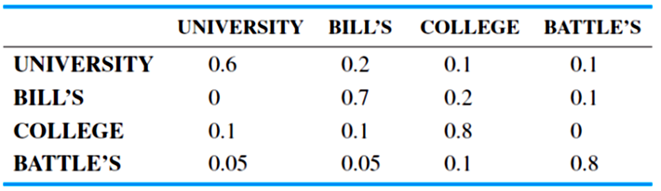
As a result of a recent survey of students at the University of South Wisconsin, it was determined that the university-owned bookstore currently has 40% of the market. The other three bookstores—Bill’s, College, and Battle’s—split the remaining initial market share equally. Given these initial market shares and the same state probabilities, what are the market shares for the next period? What impact do the initial market shares have on each store for the next period? What is the impact on the steady-state market shares?

